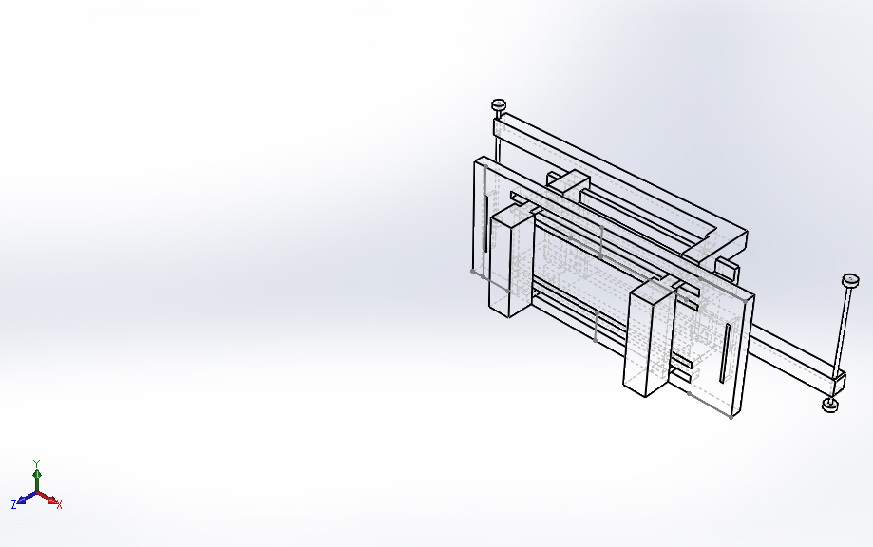 | Simulation of Assem6new  Date: Saturday, May 16, 2020  Designer: Jasmine Henderson; Bao Nguyen  Study name: Nonlinear Stainless Steel 50lb-f Part 4-Handles-T Shape]  Analysis type: Nonlinear - Dynamic  Table of Contents  Description 1  Assumptions 2  Model Information 2  Study Properties 6  Units 6  Material Properties 7  Loads and Fixtures 8  Connector Definitions 9  Contact Information 10  Mesh information 12  Sensor Details 14  Resultant Forces 14  Beams 14  Study Results 15  Conclusion 17

Description
No Data

Assumptions

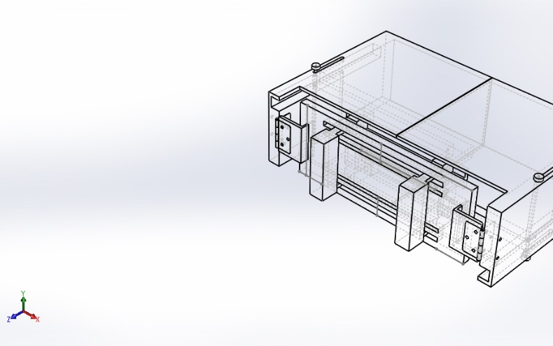  Original Model | 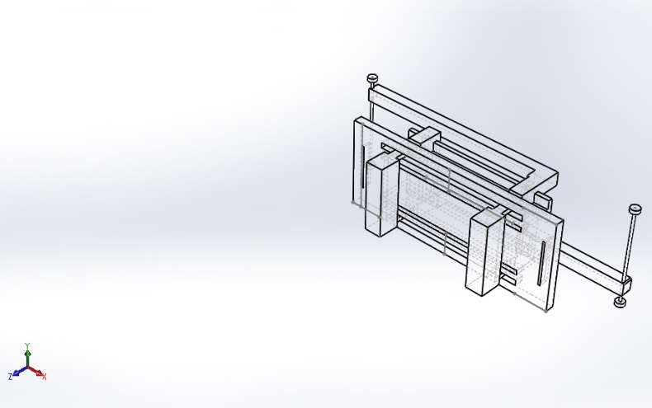  Model Analyzed

Model Information

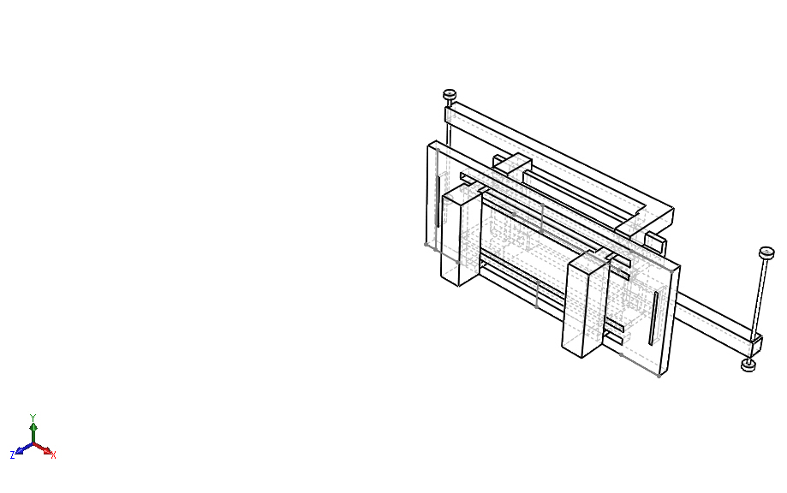
Model name: Assem6new
Current Configuration: Default
Solid Bodies
Document Name and Reference | Treated As | Volumetric Properties | Document Path/Date Modified
Cut-Extrude8  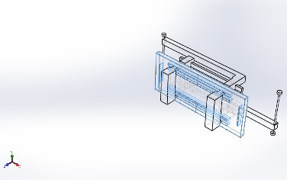 | Solid Body | Mass:0.213714 kg  Volume:2.73992e-05 m^3  Density:7,800 kg/m^3  Weight:2.09439 N | C:\Users\jvd4618\Downloads\Part4.SLDPRT  May 16 04:05:59 2020
Cut-Extrude6  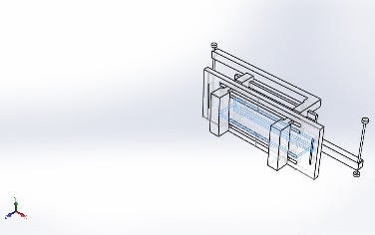 | Solid Body | Mass:0.0581577 kg  Volume:7.45611e-06 m^3  Density:7,800 kg/m^3  Weight:0.569945 N | C:\Users\jvd4618\Downloads\Part9 (2).SLDPRT  May 16 04:05:50 2020
Cut-Extrude6  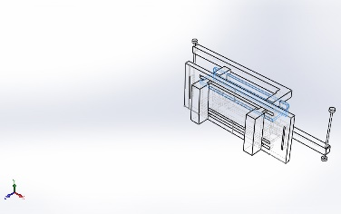 | Solid Body | Mass:0.0581577 kg  Volume:7.45611e-06 m^3  Density:7,800 kg/m^3  Weight:0.569945 N | C:\Users\jvd4618\Downloads\Part9 (2).SLDPRT  May 16 04:05:50 2020
Cut-Extrude2  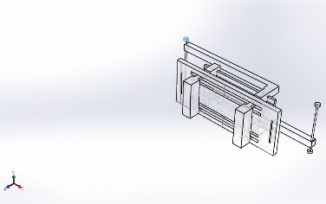 | Solid Body | Mass:0.000306186 kg  Volume:3.92546e-08 m^3  Density:7,800 kg/m^3  Weight:0.00300062 N | C:\Users\jvd4618\Downloads\capon.SLDPRT  May 16 04:06:31 2020
Cut-Extrude2  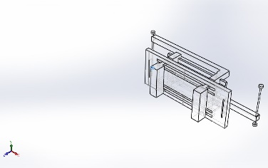 | Solid Body | Mass:0.000306186 kg  Volume:3.92546e-08 m^3  Density:7,800 kg/m^3  Weight:0.00300062 N | C:\Users\jvd4618\Downloads\capon.SLDPRT  May 16 04:06:31 2020
Cut-Extrude2  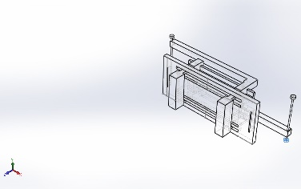 | Solid Body | Mass:0.000306186 kg  Volume:3.92546e-08 m^3  Density:7,800 kg/m^3  Weight:0.00300062 N | C:\Users\jvd4618\Downloads\capon.SLDPRT  May 16 04:06:31 2020
Cut-Extrude2  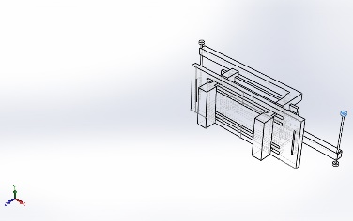 | Solid Body | Mass:0.000306186 kg  Volume:3.92546e-08 m^3  Density:7,800 kg/m^3  Weight:0.00300062 N | C:\Users\jvd4618\Downloads\capon.SLDPRT  May 16 04:06:31 2020
Boss-Extrude1  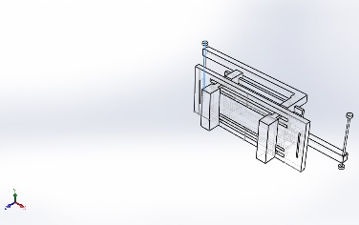 | Solid Body | Mass:0.000552139 kg  Volume:7.0787e-08 m^3  Density:7,800 kg/m^3  Weight:0.00541096 N | C:\Users\jvd4618\Downloads\connection.SLDPRT  May 16 04:06:29 2020
Boss-Extrude1  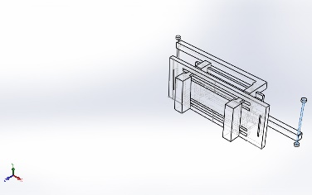 | Solid Body | Mass:0.000552139 kg  Volume:7.0787e-08 m^3  Density:7,800 kg/m^3  Weight:0.00541096 N | C:\Users\jvd4618\Downloads\connection.SLDPRT  May 16 04:06:29 2020
Boss-Extrude1  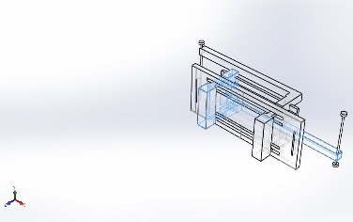 | Solid Body | Mass:0.126596 kg  Volume:1.62302e-05 m^3  Density:7,800 kg/m^3  Weight:1.24064 N | C:\Users\jvd4618\Downloads\partpsecial1.SLDPRT  May 16 04:05:47 2020
Boss-Extrude1  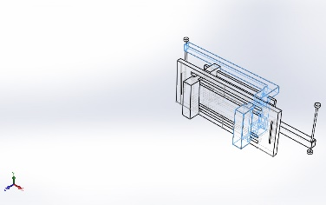 | Solid Body | Mass:0.126596 kg  Volume:1.62302e-05 m^3  Density:7,800 kg/m^3  Weight:1.24064 N | C:\Users\jvd4618\Downloads\partpsecial1.SLDPRT  May 16 04:05:47 2020

Study Properties
Study name | Nonlinear Stainless Steel 50lb-f Part 4-Handles-T Shape]
Analysis type | Nonlinear - Dynamic
Mesh type | Solid Mesh
Start time | 0 Seconds
End time | 1 Seconds
Time increment | Auto stepping
Large displacement formulation: | On
Update load direction with deflection: | On
Large strain formulation: | Off
Save data for restarting the analysis | Off
Thermal Effect: | On
Thermal option | Include temperature loads
Zero strain temperature | 298 Kelvin
Solver type | FFEPlus
Incompatible bonding options | Simplified
Control technique: | Force
Iterative technique: | NR(Newton-Raphson)
Integration Method | Newmark
Result folder | SOLIDWORKS document (C:\Users\jvd4618\Downloads)

Units
Unit system: | SI (MKS)
Length/Displacement | mm
Temperature | Kelvin
Angular velocity | Rad/sec
Pressure/Stress | N/m^2

Material Properties
Model Reference | Properties | Components
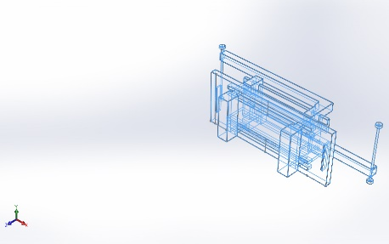 | Name: Stainless Steel (ferritic)  Model type: Linear Elastic Isotropic  Default failure criterion: Max von Mises Stress  Yield strength: 1.72339e+08 N/m^2  Tensile strength: 5.13613e+08 N/m^2  Elastic modulus: 2e+11 N/m^2  Poisson's ratio: 0.28  Mass density: 7,800 kg/m^3  Shear modulus: 7.7e+10 N/m^2  Thermal expansion coefficient: 1.1e-05 /Kelvin | SolidBody 1(Cut-Extrude8)(Part4-1),  SolidBody 1(Cut-Extrude6)(Part9 (2)-1),  SolidBody 1(Cut-Extrude6)(Part9 (2)-3),  SolidBody 1(Cut-Extrude2)(capon-5),  SolidBody 1(Cut-Extrude2)(capon-6),  SolidBody 1(Cut-Extrude2)(capon-7),  SolidBody 1(Cut-Extrude2)(capon-8),  SolidBody 1(Boss-Extrude1)(connection-3),  SolidBody 1(Boss-Extrude1)(connection-4),  SolidBody 1(Boss-Extrude1)(partpsecial1-1),  SolidBody 1(Boss-Extrude1)(partpsecial1-2)
Curve Data:N/A

Loads and Fixtures
Fixture name | Fixture Image | Fixture Details
Fixed-1 | 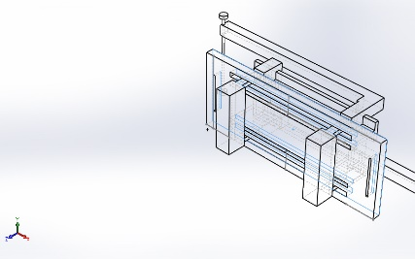 | Entities: 1 face(s)  Type: Fixed Geometry
Resultant Forces
Components | X | Y | Z | Resultant
Reaction force(N) | 0 | 0 | 0 | 1e-33
Reaction Moment(N.m) | 0 | 0 | 0 | 0

On Flat Faces-2 | 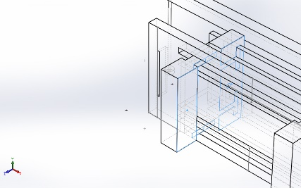 | Entities: 4 face(s)  Type: On Flat Faces  Translation: ---, ---, -0.63  Units: in
Resultant Forces
Components | X | Y | Z | Resultant
Reaction force(N) | -1.28198 | 0 | 0 | 1.28198
Reaction Moment(N.m) | 0 | 0 | 0 | 0

On Flat Faces-3 | 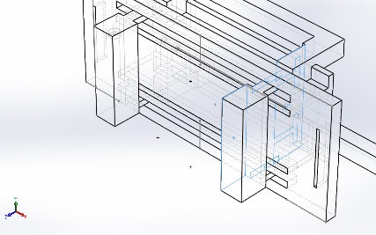 | Entities: 4 face(s)  Type: On Flat Faces  Translation: ---, ---, -0.63  Units: in
Resultant Forces
Components | X | Y | Z | Resultant
Reaction force(N) | 0.902846 | 0 | 0 | 0.902846
Reaction Moment(N.m) | 0 | 0 | 0 | 0

Load name | Load Image | Load Details
Force-2 | 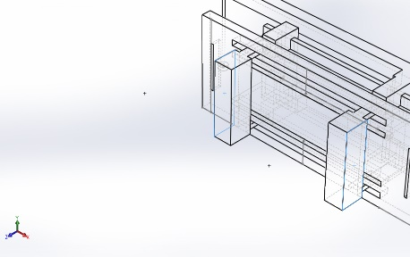 | Entities: 2 face(s)  Type: Apply normal force  Value: 50 lbf

Connector Definitions
No Data

Contact Information

Contact | Contact Image | Contact Properties
Contact Set-2 | 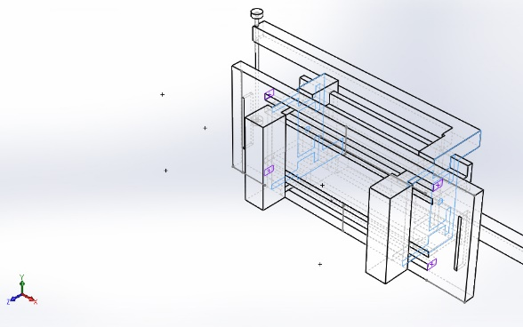 | Type: No Penetration contact pair  Entities: 6 face(s)  Friction Value: 0.05  Advanced: Surface to surface
Contact Set-5 | 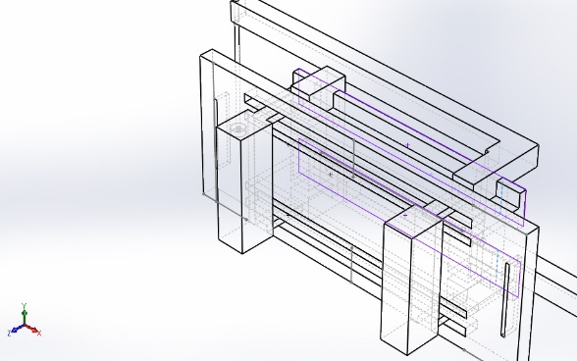 | Type: No Penetration contact pair  Entities: 2 edge(s), 2 face(s)  Advanced: Node to surface
Contact Set-6 | 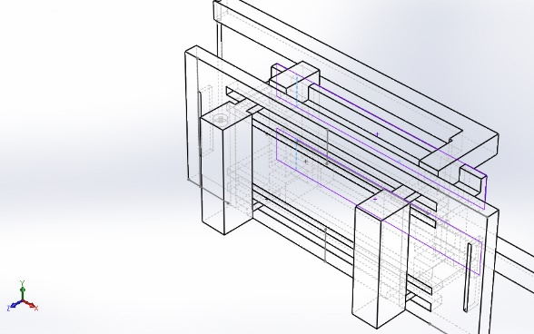 | Type: No Penetration contact pair  Entities: 2 edge(s), 2 face(s)  Advanced: Node to surface
Contact Set-7 | 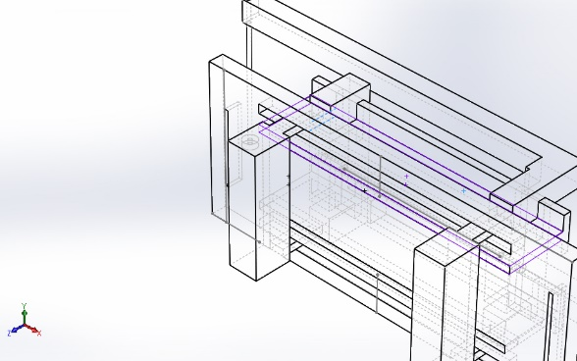 | Type: No Penetration contact pair  Entities: 2 edge(s), 2 face(s)  Advanced: Node to surface
Contact Set-9 | 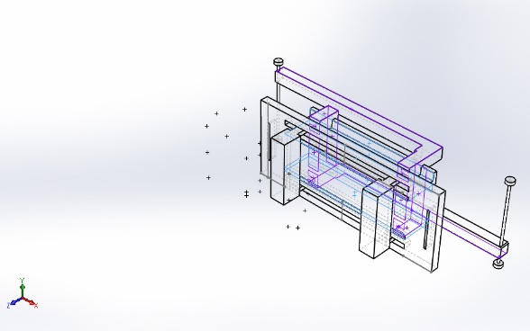 | Type: No Penetration contact pair  Entities: 19 face(s)  Advanced: Node to surface
Component Contact-1 | 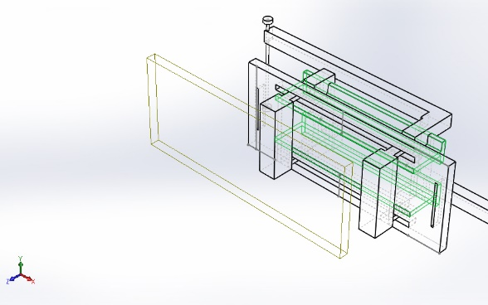 | Type: Bonded  Components: 1 component(s), 2 Solid Body (s)  Options: Compatible mesh
Component Contact-2 | 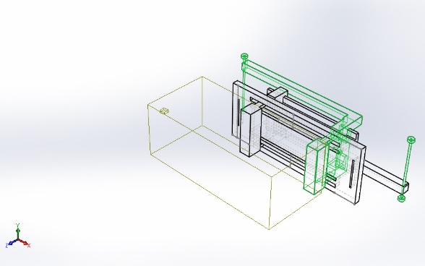 | Type: Bonded  Components: 2 component(s), 6 Solid Body (s)  Options: Compatible mesh

Mesh information
Mesh type | Solid Mesh
Mesher Used: | Curvature-based mesh
Jacobian points | 4 Points
Maximum element size | 0.31609 in
Minimum element size | 0.0632181 in
Mesh Quality Plot | High
Remesh failed parts with incompatible mesh | Off

Mesh information - Details
Total Nodes | 16532
Total Elements | 8625
Maximum Aspect Ratio | 23.889
% of elements with Aspect Ratio < 3 | 67.9
% of elements with Aspect Ratio > 10 | 0.394
% of distorted elements(Jacobian) | 0
Time to complete mesh(hh;mm;ss): | 00:00:02
Computer name: | CEAS-CAE-I03
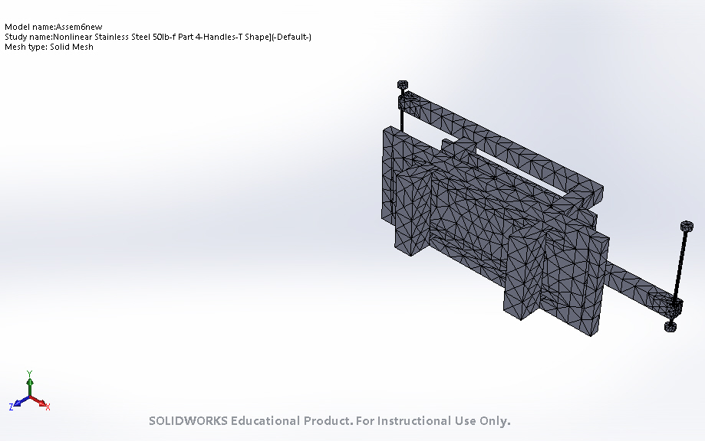

Mesh Control Information:
Mesh Control Name | Mesh Control Image | Mesh Control Details
Control-2 | 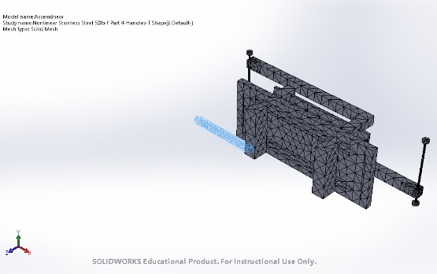 | Entities: 1 Solid Body (s)  Units: in  Size: 0.0676625  Ratio: 0.0676625

Sensor Details
No Data

Resultant Forces

Reaction forces
Selection set | Units | Sum X | Sum Y | Sum Z | Resultant
Entire Model | N | -0.379138 | 0 | 0 | 0.379138

Reaction Moments
Selection set | Units | Sum X | Sum Y | Sum Z | Resultant
Entire Model | N.m | 0 | 0 | 0 | 0

Beams
No Data

Study Results

Name | Type | Min | Max
Stress1 | VON: von Mises Stress at Step No: 100(8.488e-315 Seconds) | 0.000e+00 N/m^2  Node: 1 | 3.474e+06 N/m^2  Node: 10712
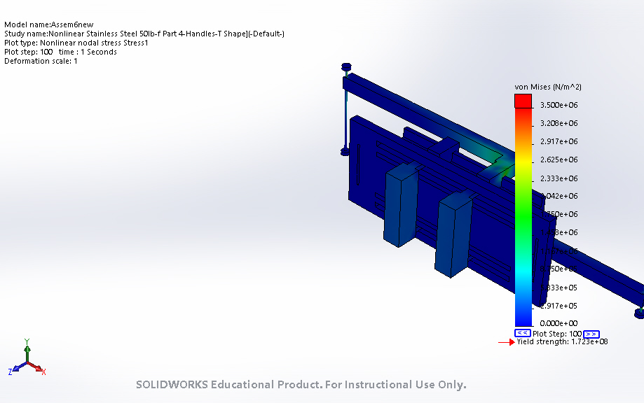
Assem6new-Nonlinear Stainless Steel 50lb-f Part 4-Handles-T Shape]-Stress-Stress1

Name | Type | Min | Max
Displacement1 | URES: Resultant Displacement at Step No: 100(8.488e-315 Seconds) | 0.000e+00 mm  Node: 1 | 1.601e+01 mm  Node: 4943
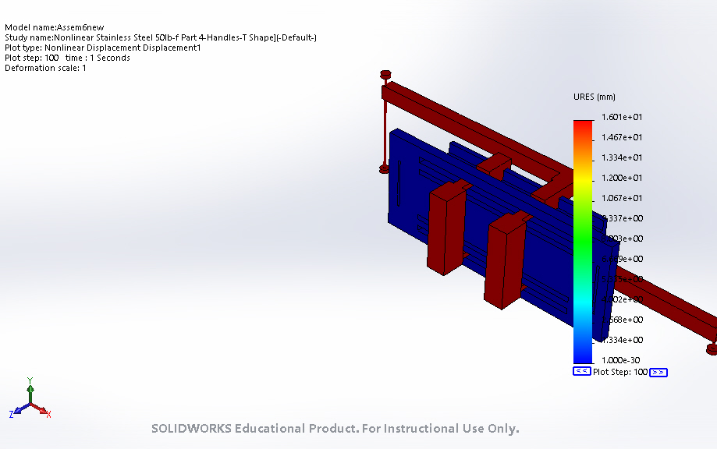
Assem6new-Nonlinear Stainless Steel 50lb-f Part 4-Handles-T Shape]-Displacement-Displacement1

Name | Type | Min | Max
Strain1 | ESTRN: Equivalent Strain at Step No: 100(8.488e-315 Seconds) | 0.000e+00  Element: 1 | 9.952e-06  Element: 3125
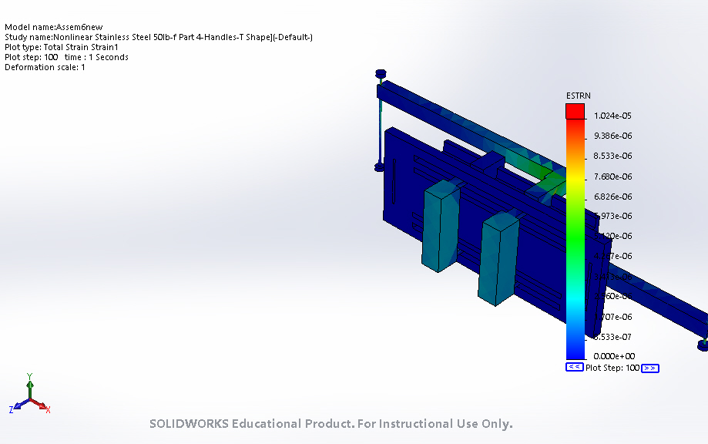
Assem6new-Nonlinear Stainless Steel 50lb-f Part 4-Handles-T Shape]-Strain-Strain1

Hinge Stress Analysis

Spring Stress Result

Conclusion

